Prices
£ 3.70 Individual Class
Price available on request

Health & Wellbeing Timetable

www.ymcasthelens.org.uk
01744 455030
North Road
St Helens, WA10 2TJ

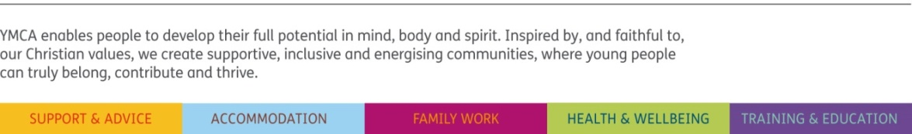
Monday | Tuesday | Wednesday | Thursday | Friday | Saturday
10.30 – 11.30  Tai Chi – Margaret  Dance Studio | 9.45 – 10.45  Forever Young – Lesley  Large Gym | 10.00 – 11.30  Yoga – Anna  WPH | 10.00 – 11.00  Tai Chi – Denise  WPH | 13.30 – 15.30  Line Dancing – Best of Friends  Large Gym | 9.00 – 10.00  Irish Dancing – Beginners – Kings Academy - WPH
14.30 – 15.30  Referral Circuit  Linda | 11.15 – 12.15  Referral Circuit – Alan  Large Gym | 14.30 – 15.30  Heart Smart  Linda  Large Gym | 11.00 – 12.00  Referral Circuit  Alan  Large Gym | 17.30 – 18.30  Tap & Modern  Mrs Horabin  Dance Studio | 9.00 – 13.00  Irish Dancing  Kings Academy  Large Gym
17.00 – 19.30  Tap & Modern  Mrs Horabin  Dance Studio | 13.15 – 15.45  Sequence Dancing - Anne & David  Large Gym | 16.30 – 18.00  Piano Lessons –  Mrs Horabin  Dance Studio | 18.15-19.15  Family Fun Fit  Robin (10-18yrs)  Large Gym |  | 9.30 – 13.30  Ballet/Dance –  Mrs Horabin  Dance Studio
18.30 – 21.30  Irish Dancing –  Kings Academy  Large Gym | 16.30 – 18.00  Piano Lessons – Mrs Horabin  Dance Studio | 17.45 – 19.15  Cardiac – Healthy Living  Large Gym | 19.30 – 21.00  Yoga - Anna  WPH | 18.00 – 19.00  Beavers  Large Gym | 10.30 – 11.30  Jujitsu – Brian  WPH
 | 17.30 – 19.30  Healthy Living Team  Large Gym | 17.45 – 18.45  Zumba – Danielle  WPH | 20.00 – 22.00  St. Helens  Badminton  Large Gym | 19.30 – 20.30  Cubs  Large Gym | 12.00 – 13.30  Yoga – Anna  WPH
 |  | 19.00 – 20.00  Ballet Size-  Dance Studio | 19.00 – 21.00  Irish Dancing  Dance Studio | 19.30 – 21.30  Scouts  Dance Studio
 | 19.30 – 20.30  Dancing - Neil  Dance Studio | 19.00 – 20.30  Yoga – Anna  WPH
 | 20.00 – 21.30  Adult Irish Dancing  Kings Academy  Large Gym | 19.30 - 21.30  Aikido  Large Gym
All classes are suitable from beginner level. Badminton Courts available for hire. *Children’s classes
24/01/18

